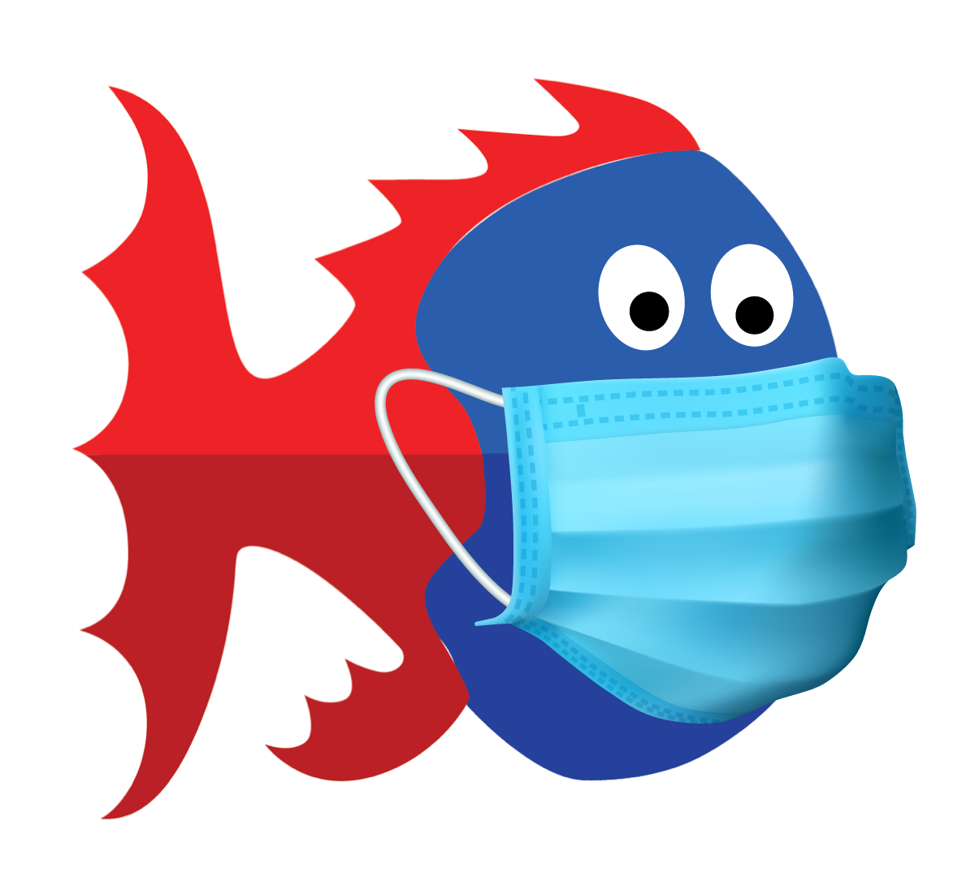

WRASA RETURN TO SWIMMING POLICY AND PROCEDURES
(COVID-19)

As of June 29, 2020

WRASA COVID OFFICER: Janie Neves Cell 778 549 8629
HEAD COACH: Rachel Brownrigg Cell 778 998 7224
PRESIDENT: Sue Fack Cell 778 222 2125

Table of Contents
INTRODUCTION 3
Disclaimer 3
GENERAL INFORMATION FOR ALL MEMBERS 4
How Coronavirus Spreads 4
Symptoms of COVID-19 4
WRASA COVID-19 Officer 4
SWIMMERS 5
Health Questionnaire 5
Best Practices for Athletes 5
Arrival Protocol 6
Equipment 6
Dryland Protocols 6
Lane Assignments and Density 7
Post Swimming Protocol 8
PARENTS 9
Health Questionnaire 9
Best Practices for Parents 9
Drop off and Pick up 10
Communication 10
Protocols for Maintaining a Safe Training Environment 10
COACHES 11
General Notes 11
Health Screening 11
Best Practices for Coaches 11
WorkSafeBC Requirements 12
Facility Requirements 12
Monitoring and Attendance 12
Outbreak Response Procedure for Coaches 13
First Aid Expectations 13
Program flow 13
Appendix A 15
WRASA ILLNESS AND POSITIVE TEST PROTOCOLS 15
Appendix B 16
Indemnity Agreements 16
Appendix C 17
WRASA Participation Agreement 17
Appendix D 18
Sunnyside Specific Procedures 18
Figure A: Sunnyside Pool Satellite Image 20
Figure B: Sunnyside Swimmer Placement in Water 21

INTRODUCTION

In an effort to facilitate the safe return to the pool and the sport of competitive swimming, WRASA has implemented the following guidelines, operational procedures and policies that all members must adhere to in order to ensure best practices during this time of “new normal”. These policies are built from the resources from the following groups and the “5 principles”.

- BCSSA Return to Swimming and Aquatic Sports
- Swim BC Return to Swimming- Swim BC
- Swimming Canada Return to Swimming -SNC
- BCPRA Restarting Operations
- Via Sport Return to Sport
- WorkSafeBC Return to Safe Operations

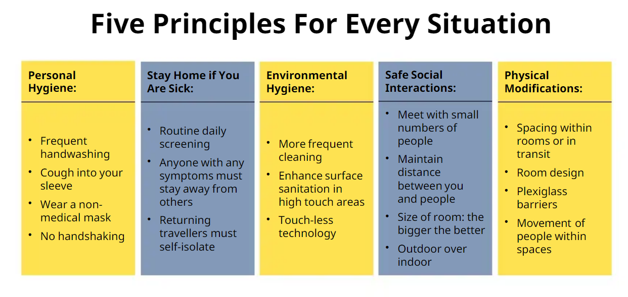

Disclaimer
- While the Provincial Government has limited the liability risk to teams during the COVID-19 (BC Liability protection announcement), safety for everyone is still first and foremost.
  - It is up to each and every person to reduce the infection, or spread of COVID-19
  - It is the responsibility of each and every person to assess the risk, and decide their own personal risk of participation within the team
- While all efforts are made to provide the best possible information available, members should understand that this is a live document and updates or changes may happen
  - Currently this document is based off BC Restart Plan “Phase 3”
- WRASA will do its best to keep the membership up to date with the ever changing environment, however it is the responsibility of the membership to stay informed

GENERAL INFORMATION FOR ALL MEMBERS

How Coronavirus Spreads
- Human coronaviruses cause infections of the nose, throat and lungs. They are most commonly spread from an infected person through:
  - respiratory droplets generated when they cough or sneeze
  - close, prolonged personal contact, such as touching or shaking hands
  - touching something with the virus on it, then touching the mouth, nose or eyes before washing the hands
- Current evidence suggests person-to-person spread is efficient when there is close contact
(Source used - Government of Canada public health)

Symptoms of COVID-19
- The symptoms of COVID-19 are similar to other respiratory illnesses, including the flu and common cold. These symptoms include
- Fever
- Chills
- Cough
- Shortness of breath
- Sore throat and painful swallowing
- Stuffy or runny nose
- Loss of sense of smell
- Headache, muscle aches
- Fatigue and loss of appetite

- People infected with COVID-19 may experience little or no symptoms, with illness ranging from mild to severe. Some people are more vulnerable to developing severe illness or complications from COVID-19, including older people, those with compromised immune systems or chronic health conditions. (Source used - Swim BC - Return to Swimming)

- For a complete understanding about COVID-19, please refer to one of the many credible sources including:
  - Fraser Health
  - BC Centre for Disease Control

WRASA COVID-19 Officer
- WRASA has created a WRASA COVID-19 Officer position. This person is responsible for:
    - monitoring the overall health of the team
    - keeping apprised of COVID-19 updates within the province
    - assist in the development of WRASA’s plan, education and enforcement

SWIMMERS

Health Questionnaire
- Swimmers are required to complete the WRASA Health Questionnaire each day before attending all workouts.
  - Legal guardians will need to complete for swimmers aged 12 and under.
  - Swimmers that do not have the questionnaire completed prior to attending the workout will not be able to participate in dryland or water sessions that day.
  - Submission deadline for the WRASA Health Questionnaire is 21:00 the night prior to each workout.
- If swimmers answer YES to any question on the health questionnaire they must:
  - Not attend the workout under any circumstance.
  - Inform WRASA COVID-19 Officer and Head Coach.
  - Follow WRASA Illness and Positive Test Protocols (Appendix A).
- Coaches will review questionnaire results daily to confirm all questions have been answered and that any abnormal responses are noted to the COVID-19 Officer and Head Coach.

Best Practices for Athletes
- Prior to participating in any session, athletes and parents must participate in a Zoom orientation meeting to address guidelines and protocols.
- Keep a minimum of 2 meters from anyone outside their household at all times.
  - Swimmers are not to assist other swimmers outside their household with equipment such as goggles, caps, suits, etc…
  - Coaches will not be performing physical manipulations/corrections on athletes.
  - The coach will wear a mask during each dryland and workout session. In a medical emergency, the coach will wear gloves in addition to a mask.
  - Swimmers will maintain appropriate distance from facility staff members throughout the duration of the time spent at the facility.
- Do not greet others with any actions (handshakes, hugging, high fives) that involve physical contact.
- Do not share food, drinks, or equipment with teammates.
- Avoid touching their eyes, nose and mouth.
- Frequently wash hands with soap and water or, if not accessible, use hand sanitizer.
  - Hand sanitizer is part of an athletes required equipment.
- Cough or sneeze into sleeves.
- Athletes must follow the entry and exit policies for Sunnyside Outdoor Pool (Appendix D).
- Athletes must follow the directions of the WRASA coaches and facility staff with regards to physical distancing procedures in place.
  - Failure to follow staff direction, facility procedures, and WRASA procedures may result in the removal of the athlete from the group training environment.
  - Athletes must follow physical markers (cones, signs, lines, stickers, etc…) that indicate appropriate spacing while on deck or in dryland areas.
- Athletes are to act responsibly and promote appropriate behaviour on social media with their peers.
- Athletes are encouraged to remain in the local community throughout Phase 3.

Arrival Protocol
- Swimmers should arrive no earlier than 10 mins before their scheduled dryland time.
  - Swimmers that arrive earlier are asked to remain in the vehicle until the appropriate time (or signalled by the coach to leave their vehicle).
  - Swimmers who are being dropped off will do so at the drop off parking lot designated for that practice and proceed to their designated dryland zone (Appendix D).
    - Should swimmers drive to the pool themselves, they will park their car at the designated parking lot for the duration of the practice.
  - 12 and under swimmers must be escorted by parents to the dryland zone.
- Swimmers who are arriving more than 10 mins after their dryland begins are asked not to come in order to prevent crossover because they would be arriving when swimmers are leaving the pool.
- Upon arrival, swimmers will proceed to a well-marked designated area (dryland zone) outside of the facility and be met by a coach as indicated in Appendix D, Figure B.
  - Coaches will verify that the WRASA Health Questionnaire for that day has been filled out.
  - If not completed that swimmer is unable to participate that day.
- Physical distance rules are in effect at all times.
- Swimmers are asked to show up with suits already on and in dryland gear.
- Swimmers should use washroom facilities at home before arriving at the pool location.

Equipment
- Swimmers must ensure that they are dressed appropriately for dryland and swimming activities. This includes all weather conditions.
- Required equipment includes:
  - Goggles
  - Pull buoy
  - Pool workout attire
  - Water bottle (swimmers must have a water bottle prefilled at home before arrival)
  - Fins
  - Garbage bag (for rainy days)
  - Sunscreen (applied before arrival to workout)
  - Hand sanitizer
  - Runners
  - Dryland workout attire
  - Rain gear
  - Towel
- The only swim equipment accepted are pull buoys and fins (no mesh bags, etc...).
- The use of snorkels will not be permitted at any time.
- Swimmers are asked to place their swim bag in designated spots as noted in Appendix D, Figure B, and then move to assigned lanes and slot allocation.
- Swimmers will not be permitted to share equipment.

Dryland Protocols
- Athletes will be spaced at least 4 m apart in the designated dryland zone.
- Athletes will place their bag next to themselves and arrange themselves in a clockwise direction as shown in Appendix D, Figure A.
- At the end of session, athletes will leave in the order 1 through to 6 (or 7 in the case of group A).

Lane Assignments and Density
- Lane density (number of swimmers in the pool) has been determined by a number of factors, including physical distance requirements, city policy and other regulatory bodies.
  - At this time WRASA will operate at the capacity of 6 swimmers per lane, 7 swimmers per lane in the case of group A (see copy of Figure B from Appendix D below).
- Swimmers’ lane assignment and lane placement (within the lane) has been determined by the coaches, creating the best “training lane” available.
  - Each swimmer is given a group (A through J) and lane placement (1 through 6, or 1 through 7 in the case of group A).
  - Swimmers must stay in their respective allocated placement as noted in Appendix D.
  - Swimmers will not be able to overtake each other during workouts.
  - Coaches will continually asses lane and group placements and will make changes to ensure sufficient social distancing measures if necessary.

Figure B: Sunnyside Swimmer Placement in Water
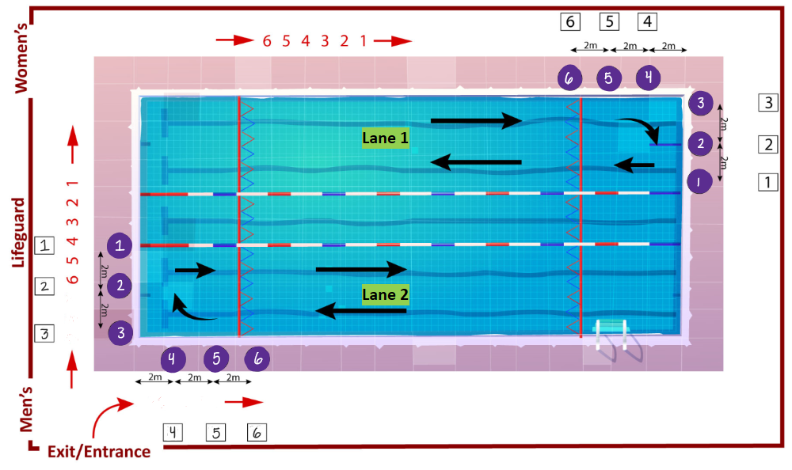

- Group size has been determined by maintaining physical distance requirements, creating a safe training environment, and the ability and maturity of swimmers. All dryland and water workouts have been capped at 7 swimmers with up to 4 coaches present. Given that the pool is 30 m long, if the Head Coach deems it safe, they may increase the number of swimmers to 8 per double lane.

Post Swimming Protocol
- Swimmers are not allowed to access the changing rooms or showers.
- Swimmers must leave the pool immediately and follow exit procedures in Appendix D.
  - Swimmers are not allowed to linger on the pool deck or in the dryland zone.
  - Swimmers must walk to designated pick-up parking lots at their numbered marker.
  - If swimmers need to leave early they must inform their coach and get picked up from Parking Lot 3 (Appendix D, Figure A).
- As per Safe Sport guidelines and club policy, NO DECK CHANGING is permitted
  - Swimmers must remove dryland clothing in designated dryland zones before entering pool vicinity.
- Swimmers must take all swim equipment home with them after each session to be sanitized.

PARENTS

Health Questionnaire
- The daily WRASA Health Questionnaire is the WRASA version of the BC COVID-19 Self-Assessment Tool.
- Swimmers are required to complete the WRASA Health Questionnaire each day before attending any workouts that day.
  - Legal guardians need to complete the questionnaire for 12 and under swimmers.
- If swimmers answer YES to any question on the health questionnaire they must:
  - Not attend the workout under any circumstance.
  - Inform WRASA COVID-19 Officer and Head Coach.
  - Follow WRASA Illness and Positive Test Protocols (Appendix A).
- Swimmers that do not have the questionnaire completed before 21:00 the night before will not be able to participate in dryland or water sessions that day.
- Coaches will review questionnaire results daily to confirm all questions have been answered and that any abnormal responses are noted to the COVID-19 Officer and Head Coach.

Best Practices for Parents
- Prior to participating in any session, athletes and parents must participate in a Zoom orientation meeting to address guidelines and protocols.
- Keep a minimum of 2 meters from anyone outside their household at all times.
  - This includes coaches and facility staff members.
  - Parents are not to assist other swimmers outside their household with equipment such as goggles, caps, suits, etc…
- Do not greet others with actions (handshakes, hugging, high fives, etc.) that involve physical contact.
- Do not share food, drink or equipment with others.
- Avoid touching their eyes, nose and mouth.
- Frequently wash hands with soap and water, or if not accessible, use hand sanitizer.
  - Hand sanitizer is part of an athletes necessary equipment.
- Cough or sneeze into sleeves.
- Follow the directions of the WRASA coaches and facility staff with regards to physical distancing.
  - Failure to follow staff direction, facility procedures, and WRASA procedures may result in the removal of the athlete from the group training environment.
- Parents are unable to watch workouts in order to keep numbers down and mitigate risk of exposure.
  - BC is in Phase 3 and the gathering of people is still restricted.
  - This will allow WRASA to maximize the number of athletes participating.

Drop off and Pick up
- Prior to 21:00 the night before each workout, parents must have completed the WRASA Health Questionnaire for their swimmers aged 12 or under and/or ensure that the questionnaire has been completed by their children who are over the age of 12.
  - Swimmers that have not completed this daily questionnaire will not be able to participate in workouts.
- Parents are asked to drop off and pick up swimmers from the parking lot in designated areas only.
- Please keep the window of drop off and pick up to 10 min before and after workouts each day.
- If parents and swimmers arrive early, please stay in the vehicle until the appropriate time.
- Parents who are dropping their swimmers off more than 10 mins after their dryland start time are asked not to come.
- Keep a minimum of 2 meters from anyone outside their household at all times

Communication
- There will be no in person meetings set until further notice.
  - Any required parent/swimmer meetings will be conducted via Zoom with a third party present.
- Email will be the primary method of communication.
  - Ensure primary account email is an email that is checked on a regular basis.
  - Ensure that the email is verified and is receiving club emails, beyond billing emails.
  - It will be the responsibility of families to ensure that they keep their primary contact email up to date.

Protocols for Maintaining a Safe Training Environment
- While all efforts are being made to mitigate the risks of a COVID-19 infection, parents are asked to help monitor the health of their swimmers on a daily basis to help keep the risk to a minimum.
- If everyone continues to follow the “5 Principles”, the chance of a COVID-19 outbreak is low at this time. However, if an outbreak occurs with any member of the WRASA team (Swimmers, Parents, Coaches) the team protocols for illness and/or positive tests is Appendix A.
  - If an athlete answers YES to any question on the WRASA Health Questionnaire they are not to attend the workout under any circumstances.
- Before in person participation all WRASA Members (swimmers and volunteers) will be required to update their registration agreement by signing the following documentation.
  - INDEMNITY AGREEMENT (Under the age of 19) (Appendix B)
  - INDEMNITY AGREEMENT (19 years and older) (Appendix B)
  - SWIMMER PARTICIPATION AGREEMENT (Appendix C)

COACHES

General Notes
During this time of “new normal”, it is more important than ever that coaches take a leadership role with the daily operations of the team, including health screening, attendance, and the general well-being of the team.

Health Screening
- Coaches must complete the WRASA Health Questionnaire before every coaching shift.
- If a coach answers YES to any question on the health questionnaire they must:
  - Not attend the workout under any circumstance.
  - Inform WRASA COVID-19 Officer and Head Coach.
  - Follow WRASA Illness and Positive Test Protocols (Appendix A).

Best Practices for Coaches
- Prior to participating in any session, coaches must participate in a Zoom orientation meeting to address guidelines and protocols.
- Coaches should arrive 15 mins before the 1st dryland session to set up.
  - Set up will include directional flow signs/markers, placement of bag markers, lane ropes, flags, pace clock etc...
- Keep a minimum of 2 meters from anyone outside their household at all times.
  - Coaches are to refrain from assisting other swimmers outside their household with equipment such as goggles, caps, suits, etc…
  - Coaches will not be performing physical manipulations/corrections on athletes.
  - Coaches will wear a mask during the workouts session.
  - In a medical emergency, the coach will wear gloves in addition to a mask.
  - Coaches will maintain appropriate distance from other coaches and facility staff members throughout the entire duration of the time spent at the facility.
    - This includes pool storage areas when accessing equipment.
- Avoid greetings with actions (handshakes, hugging, high fives, etc) that involve physical contact.
- Avoid touching their eyes, nose and mouth.
- Frequently wash hands with soap and water or if not accessible, use hand sanitizer
  - Hand sanitizer is available for coaches’ use
- Cough or sneeze into sleeve
- Coaches must follow the entry and exit policies for Sunnyside Outdoor Pool.
- Coaches must follow the directions of facility staff with regards to physical distancing procedures in place.
  - Failure to follow staff direction, facility procedures, and WRASA procedures may result in the removal of the coach from the group training environment.
- Coaches will ensure all athletes have left the dryland zone or pool facility before leaving themselves
- Coaches are encouraged to act responsibly and promote appropriate behaviour on social media with their peers.

WorkSafeBC Requirements
- Mitigating of risk:
  - WRASA has taken all efforts to reduce risk and encourages all staff to forward any potential “issues” that have been missed or not addressed to the COVID-19 Officer and President.
  - When applicable, coaches will perform any administrative tasks from home (including writing out their practice plan on the whiteboard).
- Equipment provided:
  - Hand sanitizer for staff (swimmers are required to supply their own)
  - iPad (used for tracking attendance/check-ins and for storing session workouts).
  - PPE (mask and gloves).
    - Coaches are required to wear a mask while coaching under normal circumstances.
    - Coaches are required to wear gloves, in addition to a mask, if:
      - Their own safety is at risk.
      - Have to break the physical distance of 2 meters.
      - Attending a first aid incident.
  - Whiteboard to write out practices (coaches are responsible for their own whiteboard markers).
- Equipment not provided:
  - Stopwatch.
  - Whistle (working outdoors may be required for first-aid situations).
  - Rain gear.
  - Whiteboard markers.

Facility Requirements
- Coaches are required to ensure that swimmers follow any protocols, procedures, or policies that the facility has set out. This may include:
  - Ensure swimmers are clear of any dirt or grass before entering the pool deck and pool.
  - Coaches are responsible for setting up and taking down club pool equipment.
    - Lane ropes.
    - Flags.
    - Physical distancing markers.
    - Pace clock.
  - Only 1 coach is permitted in the storage room at a time.

Monitoring and Attendance
- Coaches are to ensure that all swimmers attending a workout have completed the WRASA Health Questionnaire before participating in the workout.
  - This can be done by checking the responses through Google Drive on a provided iPad.
  - Any abnormal responses by either a coach or swimmer must be reported to the WRASA COVID-19 Officer and Head Coach immediately.
  - Coaches are responsible for ensuring that swimmer responses remain confidential.
- Coaches are responsible to record daily attendance before dryland, using the application “Workouts for Swim Coaches” provided on their iPads.
- After practice, coaches are responsible for uploading attendance records into Swim Manager and the Daily Health Questionnaire response spreadsheet as formal records.

Outbreak Response Procedure for Coaches
- The WRASA Illness and Positive Test Protocols that apply to the athletes applies to coaches as well.
- All coaches are required to read through these protocols before participation in training sessions.

First Aid Expectations
- In the event of a first aid incident, it is the responsibility of the coaching staff present to assist the lifeguards when at a facility (under their direction).
- In the event of a first aid incident during dryland, coaches must follow WorkSafeBC protocols and wear PPE. In the event of a major emergency, contact the lifeguards.
- Any incident must be recorded using the facility’s incident report plan.
- Head Coach and the club President must be notified immediately.
- Gloves and a mask must be worn while attending any incident that involves a coach to be closer than 2 meters.

Program flow
- Group changeovers would look like:
  - Swimmers arrive for dryland no more than 10 mins before the dryland session starts.
  - After dryland swimmers remove dryland gear and place it in their swim bag. Swimmers then proceed to the marked positions on the pool deck. All equipment not in use must be stored in their swim bag.
  - When the swimming session ends, swimmers have 5 mins to clear the pool and deck.
  - The coaches have 15 minutes between swimming sessions to sanitize high touch point surfaces (markers, ladders, pace clock).
Example: Monday AM (Group names A, B, C, D, E, and F have been used for simplicity)
    - Groups A and B:
      - 5:35-5:45 am: Swimmer arrival and check in. Group A and B are dropped off at Parking Lot 1 and Parking Lot 2, respectively. Group A and B swimmers will proceed to their designated dryland zone.
      - 5:45-6:10 am: Group A and Group B perform dryland in their designated dryland zones.
      - 6:10-6:15 am: Group A and B swimmers remove dryland gear and place it in their swim bag. Group A swimmers 1-6 proceed to marked spots on the pool deck led by their group coach. Once Group A swimmers are positioned in Lane 1, Group B swimmers 1-6 proceed to Lane 2 and their marked spots on the pool deck led by their group coach.
      - 6:15-7:30: Group A swimming in Lane 1, Group B swimming in Lane 2.
      - 7:30-7:35: Group B swimmers (1-6) clear the deck and walk to Parking Lot 2 for pick up. Once group B has left the pool, Group A swimmers (1-6) will clear the deck and walk to Parking Lot 1. At both Parking Lot 1 and Parking Lot 2, each swimmer will stay at their marker until a guardian arrives.
      - 7:30-7:45: Coach sanitizes high touch point surfaces (markers, ladders, pace clock).
      - 7:35-7:45: Swimmer pick up from designated pick-up zone.

    - Groups C and D:
      - 7:05-7:15: Swimmer arrival and check in. Group C and D are dropped off at Parking Lot 1 and Parking Lot 2, respectively. Group C and D swimmers will proceed to their designated dryland zone.
      - 7:15-7:40: Group C and Group D perform dryland in their designated dryland zones.
      - 7:40-7:45: Group C and D swimmers remove dryland gear and place it in their swim bag. Group C swimmers 1-6 proceed to the marked spots on the pool deck led by their group coach. Once Group C swimmers are positioned in Lane 1, Group D swimmers 1-6 proceed to Lane 2 and their marked spots on the pool deck led by their group coach.
      - 7:45-9:00: Group C swimming in Lane 1, Group D swimming in Lane 2.
      - 9:00-9:05: Group D swimmers (1-6) clear the deck and walk to Parking Lot 2 for pick up. Once Group D has left the pool, Group C swimmers (1-6) will clear the deck and walk to Parking Lot 1. At both Parking Lot 1 and Parking Lot 2, each swimmer will stay at their marker until a guardian arrives.
      - 9:00-9:15: Coach sanitizes high touch point surfaces (markers, ladders, pace clock).
      - 9:05-9:15: Swimmer pick up from designated pick up zone.

    - Groups E and F:
      - 8:35-8:45: Swimmer arrival and check in. Group E and F are dropped off at Parking Lot 1 and Parking Lot 2, respectively. Group E and F swimmers will proceed to their designated dryland zone.
      - 8:45-9.10: Group E and Group F perform dryland in their designated dryland zones.
      - 9:10-9:15: Group E and F swimmers remove dryland gear and place it in their swim bag. Group E swimmers 1-6 proceed to marked spots on the pool deck led by their group coach. Once Group E swimmers are positioned in Lane 1, Group F swimmers 1-6 proceed to Lane 2 and their marked spots on the pool deck led by their group coach.
      - 9:15-10:15: Group E swimming in Lane 1, Group F swimming in Lane 2.
      - 10:15-10:20: Group F swimmers (1-6) clear the deck and walk to Parking Lot 2 for pick up. Once group F has left the pool, Group E swimmers (1-6) will clear the deck and walk to Parking Lot 1. At both Parking Lot 1 and Parking Lot 2, each swimmer will stay at their marker until a guardian arrives.
      - 10:15-10:30: Coaches sanitize high touch point surfaces (markers, ladders, pace clock) and remove ropes, flags, signs, and markers
      - 10:20-10:30: Swimmer pick up from designated pick-up zone.

Appendix A

WRASA ILLNESS AND POSITIVE TEST PROTOCOLS
- Inform an individual in a position of authority (Head Coach, WRASA COVID-19 Officer) immediately if, the swimmer(s) feel any symptoms of COVID-19 such as fever, chills, cough, shortness of breath, sore throat and painful swallowing, stuffy or runny nose, loss of sense of smell, headache, muscle aches, fatigue and loss of appetite.

- Assessment:
  - Swimmers will be required to respond to a pre-training health questionnaire before their practice/ activity to attest that they are not feeling any of the COVID 19 symptoms.
  - Coaches will visually monitor team members to assess any early warning signs as to the status of their health and to touch base on how they are regarding their personal safety throughout the practice/ activity.
  - If members are unsure, please have them use the BC COVID-19 Self-Assessment Tool

- If a member is feeling sick with COVID-19 symptoms:
  - They will remain at home and contact Health Link BC at 8-1-1.
  - If they feel sick and/or are showing symptoms while at practice they will be sent home immediately and have them contact 8-1-1 or a doctor for further guidance.
  - NO member may participate in a practice/activity if they are symptomatic.

- If a member tests positive for COVID-19:
  - The member will not be permitted to return to practice until they are free of the COVID-19 virus.
  - Any member who worked / practiced closely with the infected member will also be removed from club activity for at least 14 days.
  - Ensure work/practice area is closed off, cleaned and disinfected immediately and any surfaces that could have potentially been infected/ touched.

- If a member has been tested and is waiting for the results of a COVID-19 test:
  - As with the confirmed case, the member must be removed from the work/practice area.
  - The BCCDC advises any person who has even mild symptoms to stay home and call 8-1-1.
  - Other members who may have been exposed will be informed and removed from the work/practice for at least 14 days or until the diagnosis of COVID-19 is ruled out by health authorities.
  - The work/practice space will be closed off, cleaned, and disinfected immediately and any other surfaces that could have been potentially infected/ touched.

- If a member has come in to contact with someone who is confirmed to have COVID-19:
  - Members must advise their employer/coach if they reasonably believe they have been exposed to COVID-19.
  - Once the contact is confirmed, the member will be removed from the workplace/ practice for at least 14 days or as otherwise directed by public health authorities. Members who may have come into close contact with the member will also be removed from the workplace for at least 14 days.
  - The workspace/activity area will be closed off, cleaned, and disinfected immediately and any other surfaces that could have potentially been infected/touched.

- Quarantine or Self-Isolate conditions:
  - Any member has travelled outside of Canada or the province within the last 14 days is not permitted to enter any part of the facility and must quarantine and self-isolate.
  - Any member with any symptoms of COVID-19 is not permitted to enter any part of the facility and must quarantine and self-isolate.
  - Any member from a household with someone showing symptoms of COVID-19 is not permitted to enter any part of the facility and must quarantine and self-isolate.
  - Any member who is quarantined or self-isolating as a result of contact with an infected person or in families who are self-isolating, is not permitted to enter any part of the facility.

Appendix B

Indemnity Agreements

Indemnity Agreement (under the age of 19)

Indemnity Agreement (19 years and older)

Appendix C

WRASA Participation Agreement
This agreement applies to all athletes, coaches, members, volunteers, participants and family members of participants while in attendance at Club activities.

All Participants of WRASA agree to abide by the following points when entering club facilities and/or participating in club activities under the COVID-19 Response plan and the return to play (RTP) protocol.

I agree to complete the daily WRASA Health Questionnaire prior to arriving at the pool.

I agree to stay home if feeling sick and remain home for 14 days if experiencing COVID-19 symptoms.

I agree to sanitize my hands upon entering and exiting the facility, with soap or sanitizer.

I agree to sanitize the equipment I use throughout my practice with approved cleaning products provided by the club (shared and personal equipment).

I agree to continue to follow social/physical distancing protocols of staying at least 2 meters away from others.

I agree to not share any equipment during practice times.

I agree to abide by all of my clubs COVID-19 Policies and Guidelines.

I understand that if I do not abide by the aforementioned policies/ guidelines, that I may be asked to leave the club for up to 14 days to help protect myself and others around me.

I acknowledge that continued abuse of the policies and/or guidelines may result in suspension of my club membership temporarily.

I acknowledge that there are risks associated with entering club facilities and/or participating in club activities, and that the measures taken by the club and participants, including those set out above and under the COVID-19 Response Plan and Return to Sport Protocols, will not entirely eliminate those risks.

Name: ______________________________ Parent or Guardian Name: ____________________________

Date: _______________________________

Signature of Participant (over 18 years of age): _____________________________________

Signature of Parent / Guardian (if participant is a minor): _____________________________________

Appendix D

Sunnyside Specific Procedures

 | Sunnyside Pool - Figure A
Facility Bathing Load | - Phase 3: 30 people per facility maximum.
Drop Off Location (Figure A) | - Parking Lot 1: gravel off of 154 street.  - Parking Lot 2: main parking lot by playground.  - Arrive with bathing suits under dryland gear and runners on.  - Only one swim bag allowed (no equipment bag). Have equipment in a swim bag.
Dryland location (Figure A) | - Proceed to dryland zone, maintaining 2 m physical distancing (Figure A).  - Dryland zone 1: near tennis courts.  - Dryland zone 2: near playground.  - Position swimmers, 1 to 6 (or 7) as indicated, maintaining minimum 4 m separation.  - After dryland, swimmers 1-6 in dryland zone 1 proceed to Lane 1 in that order, then swimmers 1-6 in dryland zone 2 proceed to Lane 2 in that order.
Entry procedure onto deck  (Figure B) | - Swimmers from dryland zone 1 will proceed to Lane 1 and once positioned swimmers from dryland zone 2 will then proceed to Lane 2.  - Swimmers proceed around the deck to their marked station while maintaining physical distancing.  - Remove shoes and any dryland clothing at this time.  - Showers will not be available.  - Bathroom facilities can only be used one person of each gender at a time by notifying the coach first.  - Place the swim bag against the fence in line with your marked station (marked with their number inside a square).  - Place fins, pullbuoy, water bottle at pool edge (marked with their number inside a circle).
Handwashing Location | - Swimmers are required to have their own hand sanitizer.  - Sinks with soap available for restroom use only.  - One swimmer of each gender at a time in the washroom.
Swimmer Position (Figure B) | - 2 groups will be present at all time slots.  - Each group will contain 6 (or 7) swimmers of similar speeds.  - Swimmers in dryland zone 1 will swim in the eastern 2 lanes.  - Swimmers in dryland zone 2 will swim in the western 2 lanes.  - Once ready, swimmers are to remain at their bag until instructed (marked with their number inside a square).
Entry Procedure into pool and swimming  (positioning in Figure B) | - Once instructed, swimmers will enter the pool (marked with their number inside a circle).  - To start the set, Swimmer 1 leaves their station while the remaining swimmers at the wall will move to the subsequent station. 5 seconds after the Swimmer 1 leaves, Swimmer 2 sets off (from start station 1). After Swimmer 2 leaves, the remaining swimmers move to the next station. 5 seconds later, Swimmer 3 leaves (again from station 1).  - Upon completion of the set, swimmers return to their marked stations to rest and hydrate.
Washroom Procedure | - Washroom access is extremely limited.  - Swimmers should use the washroom at home before leaving their house.  - Swimmers must give notice to their coach before using the washroom in order to notify the lifeguard to open the washroom.  - Swimmers shall leave their water at their station and return to their station.  - 1 swimmer of each gender is allowed at a time in the washroom.  - Must wash hands with soap before returning to the workout. If soap is not available they must use their hand sanitizer.
Lightning/Clear Pool Procedure | - Swimmers will clear the pool, proceed to their bag marker, and follow lifeguard instructions.  - Maintain physical distancing at all times while clearing the pool and moving out of the facility.
Exit Procedure Water  (Figure A) | - Swimmers in Lane 2 leave the pool first, go directly and pick up their swim bags and leave in order (1-6) directly through the gate, whilst maintaining 2 m separation. Next, swimmers in Lane 1 leave the pool, go directly to their swim bags and leave in order (1-6) directly through the gate whilst maintaining 2 m separation.  - Swimmers wait in the pick up waiting area, whilst maintaining 2 m separation at their designated markers
Pick Up Location | - Group 1 will be picked up at the same location they were dropped off, parking lot off of 154 street .  - Group 2 will be picked up at the same location they were dropped off, the main parking lot by the playground.

Figure A: Sunnyside Pool Satellite Image
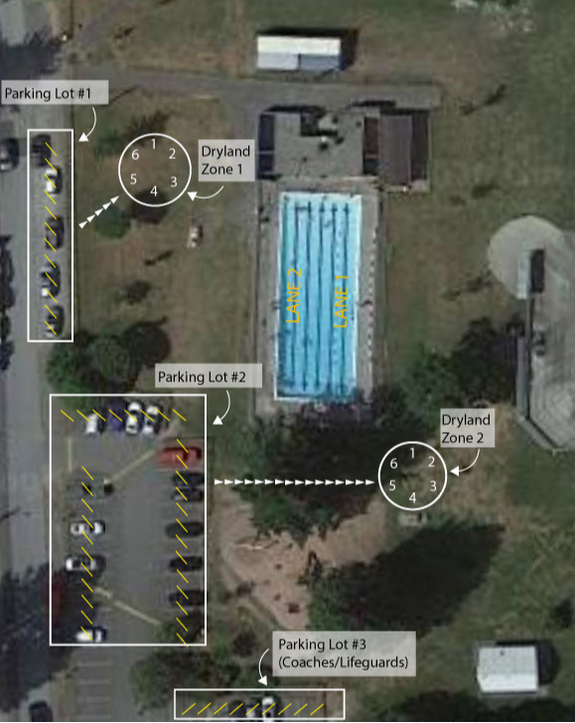

Figure B: Sunnyside Swimmer Placement in Water

